WORLD YOUTH CHESS CHAMPIONSHIPS 2008
October 19 – 31, Vung Tau - VIETNAM

FORM 1: GENERAL REGISTRATION (before August 15th 2008)

Technical Director, WYCC 2008 Organising Committee
c/o FIDE Office Singapore
7500A Beach Road #11-324, Singapore 199591
Email: ignatiusleong@pacific.net.sg; kftang@starhub.net.sg
Fax: +65 6297 7647 and +65 6352 9691
Tel: +65 96337946 (English); +65 92487863 (Spanish); +84 903 944 649 (Russian)

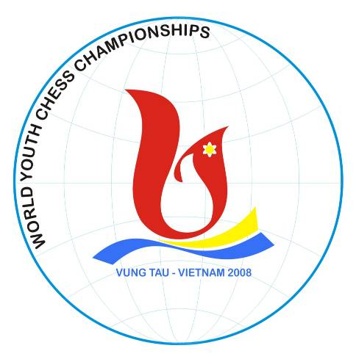

FEDERATION:

Contact person: | Tel:
Fax: | E-mail:

No. of Official Players: | Accompanying Official: 01
No. of Additional Players: | Accompanying Persons:
Total No. of Players: | Total Accompanists:

To confirm participation, payment of the Organisation Fee of 100 € (Euros) per person must be made. To confirm Hotel Booking, total payment must also be made. Copies of the bank transfers must be sent to the Organisers by email or fax.

Account Name: Intchess Asia Pte Ltd
Bank Name: DBS Bank
Address: 6 Shenton Way, DBS Building, Singapore 068809
Account Holder: Intchess Asia Pte Ltd
Account Number: 070 – 900154 – 8
IBAN Number: GB56 BARC 2032 5355 9063 33
SWIFT Address: DBSSSGSG

